**LEBANESE AMERICAN UNIVERSITY**

**USAID – HIGHER EDUCATION SCHOLARSHIP PROGRAM**

**HES - Volunteering Program Verification Form**

This form is to be used to document volunteering hours. If a student volunteers for multiple organizations, a separate form must be used for each organization. **This form must be turned in by the 28th of each month, the latest.**

I certify that the scholar Asmaa Almasri completed a total of 22 hours of service at InnovaThrive.

The hours were completed hours as per the below:

Hours # 8 (date) _2/12 – 6/12_ (initials of supervisor) __A.K.___

Hours # 5 (date) _9/12 – 13/12_ (initials of supervisor) __A.K.___

Hours # 4 date) _16/12 – 20/12 (initials of supervisor) __A.K.___

Hours # 5 date) _23/12 - 27/12 (initials of supervisor) __A.K.___

Brief description of the activities the scholar performed or participated in:

Four research papers were reviewed and refined, covering topics such as the effects of social media, transition metal catalysis mechanisms and applications, the psychology driving loyalty programs, and the psychological impact of social media. The revisions focused on improving language formality, enhancing writing style, ensuring coherence, and verifying the use of credible references.

Written feedback about the scholar’s performance:

Asmaa Almasri’s review and refinement of four research papers underscored her strong analytical and editorial skills. Her ability to enhance language formality, coherence, and reference credibility significantly improved the quality of the research, reflecting a high level of professionalism and attention to detail.

Please rate the overall performance of the scholar at your organization:

|  |  |  |  |
| --- | --- | --- | --- |
|  | Mastery (5) | Proficient (3) | Emerging (1) |
| **Problem solver** | X |  |  |
| **Engaged & Committed** | X |  |  |
| **Open-minded & multicultural** | X |  |  |

Signature

& stamp

__________________________

_

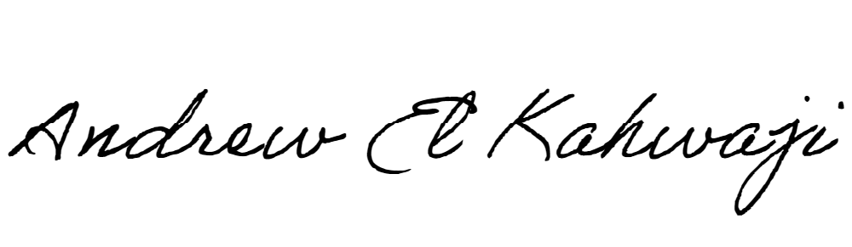

Printed Name _Andrew El Kahwaji_

Date __26/12/2024___

Email __andrew.lifesculptor.coo@gmail.com __

Phone __+961 71 914 378__